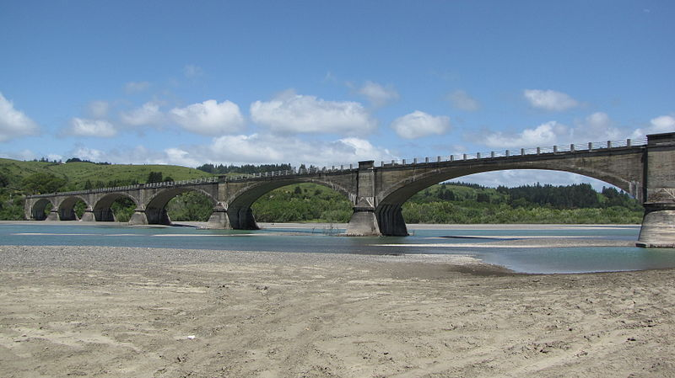
Fernbridge – The Queen of Bridges (1911 – Infinity) - Seven 190 feet spans
It is still the longest poured-in-place concrete bridge in the world.
Connecting Highway 101 with Ferndale California

The Building of Fernbridge
A Love Story by Ed Wilson

My father, James C. Wilson (4/1/1882–10/14/1961) was born in San Francisco, the son of James Wilson and Mary McCoy, an Irish immigrant. His mother died shortly after he was born and he was raised by his father who was a carpenter. At a young age he worked as his father’s helper on construction sites in San Francisco. As a young man he swam in the Pacific Ocean off the shore near Cliff House. During the same period he attended several years of elementary school.

In approximately 1897 Dad’s father died (perhaps from an accident or hard work) and he moved to Petaluma and lived with an aunt. He continued to work in construction before he became a full time carpenter. (Possible relative of Jack London – to be added)

While living in Petaluma Dad joined the National Guard (or State Militia). On April 18, 1906 the great San Francisco Earthquake occurred. The San Andreas Fault ruptured over 250 miles from south of San Francisco to above Ferndale along the Northern California Pacific Coast. Dad’s guard unit was called upon to guard the fire and earthquake damaged city of San Francisco from looters. This assignment lasted several months.

From 1906 to 1910 Dad worked hard, with many different contractors, to rebuild San Francisco and many other North Bay cities. While working with my father as a young man, he told me several times the damage in Petaluma and Santa Rosa areas was far greater than the damage to similar structures in San Francisco.

In 1910 a contractor Dad worked with for several years asked him to go to Northern California to build a very long reinforced concrete bridge near the mouth of Eel River. Dad was assured that he would be paid premium wage for his work. At that time, Dad was 28 years old and had extensive experience building forms for large concrete structures. Dad helped the contractor assemble a crew and loaded one or more steam ships “steamers” with special equipment that would be used to build the bridge. On the voyage from San Francisco to Humboldt county Dad said he was deathly sea sick and made up his mind that he would never take another ocean trip.

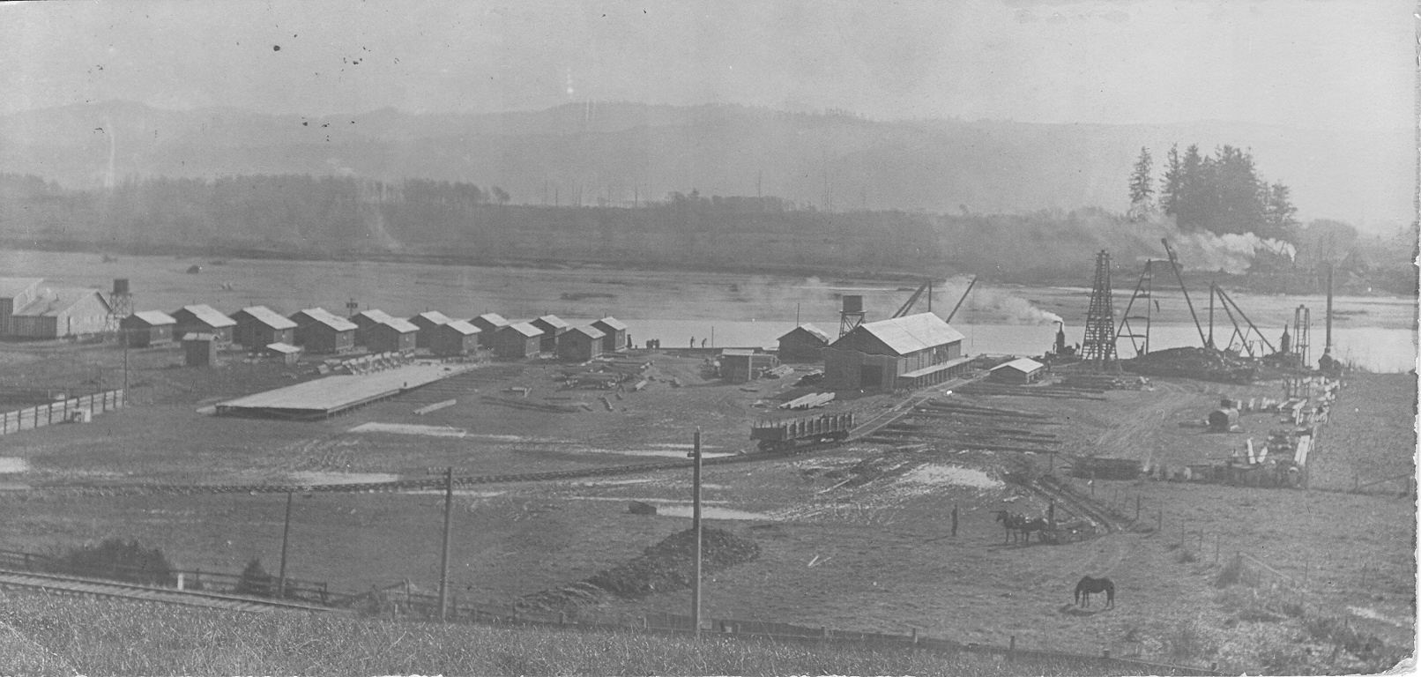

The first group of workers arrived at the bridge construction site, built the housing for the construction workers and the equipment storage and fabrication buildings, as shown above from north side of the Ell River. I believed that Dad lived at this site and was one of the leaders of the crew that constructed Fernbridge starting in March 1910.

The next step in the building of Fernbridge Bridge was to the build two temporary bridges on both sides of the new bridge, as shown below:

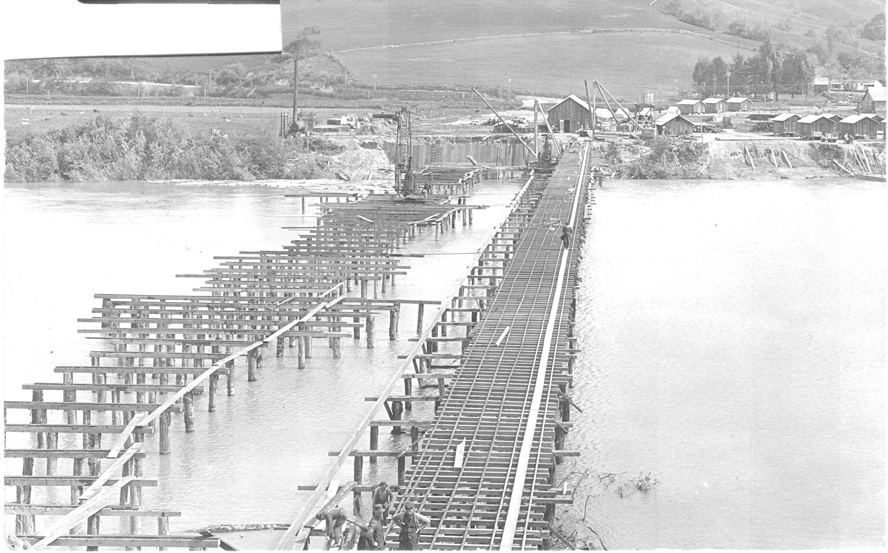

The above photo clearly indicates that that the ell river was very high and was near flood level.

that constructed Fernbridge from March 1910 to November 1911. However, he did not immediately return to San Francisco after his work on the bridge. Instead, he obtained a job at a local creamery, in addition to continuing his carpenter profession. .He told me that during the next several years he did make three trips to the San Francisco Bay area to visit family and friends. However, he did not travel by ship – he rode his bicycle to and from the Bay Area. The one way bicycle trip, over the poorly developed roads at that time, took him three days and two nights.

I have concluded the reason he decided to return to the Eel River Valley was that he met my mother – a very attractive and talented young woman.

My Mother, Jo Christen (4/17/1892–10/14/1967), whose legal name is Johana Josephine and was born in Petrolia, the oldest daughter of Edward Christen (1860 -1940) and Maria Regli (1866 – 1912). When Jo was 4 years old, the Christen family moved from Petrolia to Pleasant Point in 1896 very near the Eel River upstream from where Fernbridge was later constructed. However, in 1906 a very large flood washed away a significant part of their ranch. Within the next several years the ranch was reduced is size and they moved to another ranch at Grizzly Bluff. However, I believe the Pleasant Point property is still part of the old Edward Christen estate (Rich Christen would know for sure)

After Jo completed the eighth grade at Pleasant Point School she was trained as a seamstress. She went from home to home in the Eel river valley. She would live with a family for a few weeks and mend or make their clothes for the next year. In 1912 her Mother, Maria, died after the birth of her 15th child. Therefore, she made time to help her younger brothers and sisters with raising the family. Jo continued to do this type of work until she married Jim Wilson in September 1917 at the age of 25.

On April 17, 1910 Jo turned 18 years old when Jim Wilson, age 28, started working on the construction of Fernbridge. Since the Christen Pleasant Point ranch was very close to the Bridge, I am sure that Mom and Dad meet while the bridge was under construction – perhaps at a Saturday night dance, or, possibly at a church service (since both were Catholic).

Both Mom and Dad did not talk about their courtship during the 1911 to 1917 period. I assume that the very good Catholic Christen family had a difficult time accepting the older Irish man that was raised on the streets of San Francisco. All of Jo’s sisters and brothers married into families who were first generation Swiss emigrants. Also, they were all in the dairy business. After Jo became 25 years old she believed that it was time for her to marry. Jim, who was a happy-go-lucky 35 years old bachelor, also was ready to settle down. In addition, he had rented a dairy and was ready to change his wild ways and become a typical dairy farmer.

The Jim and Jo Wilson family tree has produced seven children, nine grandchildren, 13 great grandchildren and seven great-great grandchildren as of Oct. 3, 2011.

Fernbridge is 100 years Old
An Engineering Evaluation by Ed Wilson

The Ferndale community will celebrate the 100th birthday of the completion of Fernbridge, the Queen of Bridges, on November 11, 2011. The fact that Fernbridge has survived 100 years, in a very hostile environment near the mouth of Eel River, indicates that it is a very significant engineering and construction achievement. In addition to large floods that pounded the bridge every few years and the many major earthquakes that subjected the bridge to large dynamic displacements, the Queen has proven she has the ability to protect the Ferndale residents from isolation from the other communities in the Eel River Valley.

Fernbridge – The Queen of Bridges (1911 – Infinity) Seven 190 feet spans

Fernbridge was designed by American engineer John B. Leonard (1864-1945) who was born and educated in Michigan and finally settled in San Francisco in 1889 after many years of experience as a structural engineer. At the age of 40 he opened his own structural engineering consulting office in 1904 and designed both steel and concrete buildings and bridges in Northern California during the next 35 years.

At that time, Leonard was one of the few engineers who had the ability to design reinforced concrete buildings and bridges. Reinforced concrete technology had only evolved during the previous 40 years and many of his engineering colleagues had not accepted this new technology.

Micellanious Comments

The monumental 1906 San Francisco earthquake clearly illustrated how structures really performed after a major natural disaster. After the earthquake and fire, most of the concrete buildings did not burn and were not badly damaged by the earthquake. Most unreinforced brick structures collapsed or were badly damaged. Therefore, Leonard expertise’s in the design reinforced concrete building and bridges was in high demand after the earthquake. He would engineer many structures in post-1906 San Francisco, become increasing involved in building inspection, and ultimately designed about 45 bridges in California

My father, who walked guard after the SF earthquake and fire, concluded most wood buildings were not significantly damaged by the earthquake; however, they had very low resistance to fire. In addition, he concluded many wood structures were badly damaged due to failure of tall unreinforced brick fireplaces chimney falling on structures. Therefore, he always added additional metal reinforcement to these types of brick structures for the rest of his professional life.

During the 1906 earthquake many wood buildings were not attached to their rock or concrete foundations were knocked off their supports. Dad and his carpenter friends easily solved this critical problem with a simple and inexpensive design after the 1906 earthquake.

I was born near Ferndale in 1931, less than 20 years after the completion of the Queen. As a very young child, whenever we crossed the bridge, my father would say he built the bridge and it was the longest reinforced concrete bridge in the world. My father was born in San Francisco and first come to Ferndale, with a San Francisco Construction Company, to build the Bridge.

My Father was a carpenter, self-made engineer and rancher in the Ferndale area. As his youngest son I spent a considerable amount of time working on constructions projects and hearing his stories about the 1906 San Francisco earthquake, the construction of Fernbridge and many other projects. After I completed high school in 1950 I wanted to be a carpenter. However, the local college only offered a Structural Engineering Degree under the Department of Civil Engineering. At that point in time I did not have motivation to graduate from college. However, I enjoyed college and finally earned a D. Eng. Degree in 1963 from UC Berkeley.

Hence, at this point in time, I will attempt to comment on the very unique structural system of the Queen.

More Notes
Reinforced concrete is concrete in which reinforcement bars ("rebars"), reinforcement grids, plates or fibers have been incorporated to strengthen the concrete in tension. It was invented by French gardener Joseph Monier in 1849 and patented in 1867.^{[1]}

The word "cement" traces to the Romans, who used the term opus caementicium to describe masonry resembling modern concrete that was made from crushed rock with burnt lime as binder.
Concrete should not be confused with cement, because the term cement refers to the material used to bind the aggregate materials of concrete. Concrete is a combination of a cement and aggregate.
Cement used in construction is characterized as hydraulic or non-hydraulic. Hydraulic cements (e.g., Portland cement) harden because of hydration, chemical reactions that occur independently of the mixture's water content; they can harden even underwater or when constantly exposed to wet weather. The chemical reaction that results when the anhydrous cement powder is mixed with water produces hydrates that are not water-soluble. Non-hydraulic cements (e.g., lime and gypsum plaster) must be kept dry in order to retain their strength.

Fernbridge is a 1,320 feet (400 m) historic 1911 concrete Arch bridge at the site of an earlier ferry crossing of the Eel River, designed by American engineer John B. Leonard. Fernbridge is the last crossing before the Eel arrives at the Pacific Ocean, and anchors one end of State Route 211 leading to Ferndale, California. When built, it was named the "Queen of Bridges" and is still the longest, functional poured concrete bridge in operation in the world.^{[4]}

Construction

After 17 years of petitioning by residents of Ferndale and the Eel River valley, in 1910, Humboldt County Supervisors accepted bids for construction and work started March 20, 1910. Reinforced concrete was used because studies after the 1906 San Francisco earthquake along 296 miles (476 km) of the San Andreas Fault from Ferndale south to San Jose, California showed that reinforced concrete withstood earthquakes. The nearly quarter mile span cost $245,967 in 1910 dollars to build, and consumed millions of board feet of local redwood timber for the framing. Construction was finished and the bridge put into operation on November 8, 1911. Original wooden approach ramps were replaced with the current ramps in the 1920s.^{[7}
Leonard was born in Union City, Michigan and educated at Michigan State and the University of Michigan before going west in 1888. After brief periods in San Diego and Los Angeles, he settled in San Francisco. From 1889 he was employed there doing iron and steel engineering for various firms, including the Southern Pacific Railroad. Leonard opened his own consulting civil engineering office in 1904.
Even in the aftermath of the 1906 San Francisco earthquake, resistance to fireproof reinforced concrete was strong. Leonard's analyses of concrete's superior performance in the earthquake and fire, especially Ernest L. Ransome's two buildings at Stanford University, and a constant stream of his articles and editorials in Architect and Engineer of California, changed the city's ordinances and gained national attention.
As of 1913 Leonard was in partnership with William Peyton Day. Together they produced the pamphlet The Concrete Bridge, showing examples and analyses of Leonard's work. In 1916 Day left to form the noted San Francisco firm of Weeks & Day.
Leonard would engineer about 20 buildings in post-1906 San Francisco, become increasing involved in building inspection, and ultimately design about 45 bridges in California.

