Jan 7- 2024 Holiday Greetings from the Wilson Family

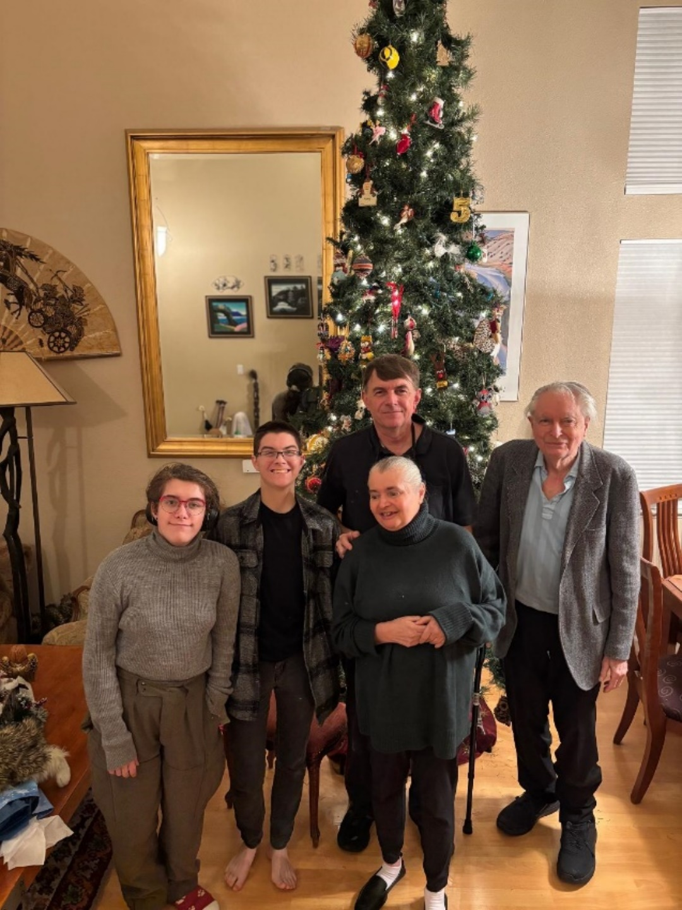

**Lee, Molly, Terri, Mike and Old Ed**

In December Molly and Lee completed all requirements for their Bachelor’s Degrees at UC Santa Cruz – which will be awarded in June. Their plan is to get their substitute credentials during the spring and start their Masters/Credential program in the summer- they have both been accepted to a program that should allow them to get both by the end of the next school year. Molly will be teaching science, and Lee history.

Terri is now 61 years old and continues to live nearby in Pleasant Hill. She still requires 24-hour care – along with her collection of stuffed animals. Mike is now her legal guardian – and is doing a great job.

Mike is staying active. The house in El Cerrito has had a lot of improvements made over the last year. In addition to wrangling the rest of us and doing jobs around the house, he’s been collecting matchbooks and watching almost every episode of *Star Trek*.

Ed has been managing the house and staying busy in the workshop. He’s been doing a lot of reading lately, and has gotten back to work on his website (edwilson.org). He’s still trading stocks and keeping his mind sharp.

